EDUCATION DELIVERY SYSTEM-CURRENT
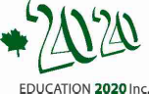
Present
2017
For profit

PROFESSIONAL ORGANIZATIONS

kindergarten & ECE

EARLY cHKindergarten

Public Schools
Citizen

MEDIA

Postsecondary
EDUCATION STORES
Private schools
SPECIALISTS
CLINICS

Tutors

4/pres/graph-2

